# **CS 1101-01: Discussion Forum Unit 4**

Godknows Egi

Bachelor of Science in Computer Science, Uopeople

CS 1101-01 - AY2024-T3: Functions and Return Values

Bianca Gilyot

February 28th , 2024

**Discussion Assignment**

Section 6.9 Debugging of your textbook lists three possibilities to consider if a function is not working.

* Describe each possibility in your own words.
* Define "precondition" and "postcondition" as part of your description.
* Create your own example of each possibility in Python code. List the code for each example, along with sample output from trying to run it.

**Explanation for 1st Possibility:**

When debugging a function the first possibility is to check if the arguments the function is getting, Maybe there’s a mismatch or violation in a “**Precondition**”, Precondition in programming is a condition or a check that runs before the other function executes. As said By Eric C.R. Hehner in his book , *A Practical Theory of Programming:***Program Theory** *(page:208)* It’s used to mean “something that’s sufficient beforehand”, This can also called guardian Code as explained on Downey, A. (2015,). Think Python: How to think like a computer scientist ,*Chapter 6 - Fruitful functions (pp. 6.8)*

**Explanation for 2nd Possibility:**

The second possibility will be to check the the **post-conditions** maybe a computation might have been violated**,** Postconditions are conditionals requirement that should be satisfied by the function before it ends and mainly return values.

**Explanation for 3rd Possibility:**

The Third possibility will be to check the return values maybe there might be a misconception in the variable storing the value. Either by the way its been implemented or used

**Example for the 1st possibility**

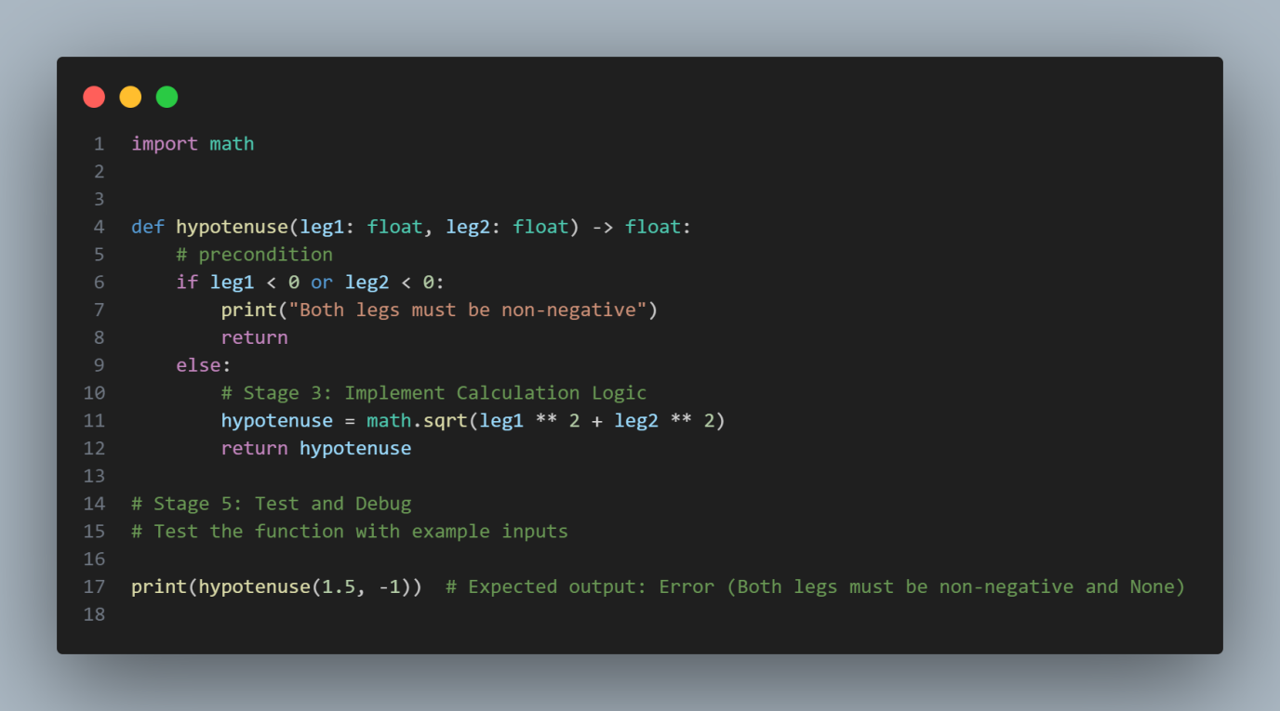

*Code for P1, fig.1*

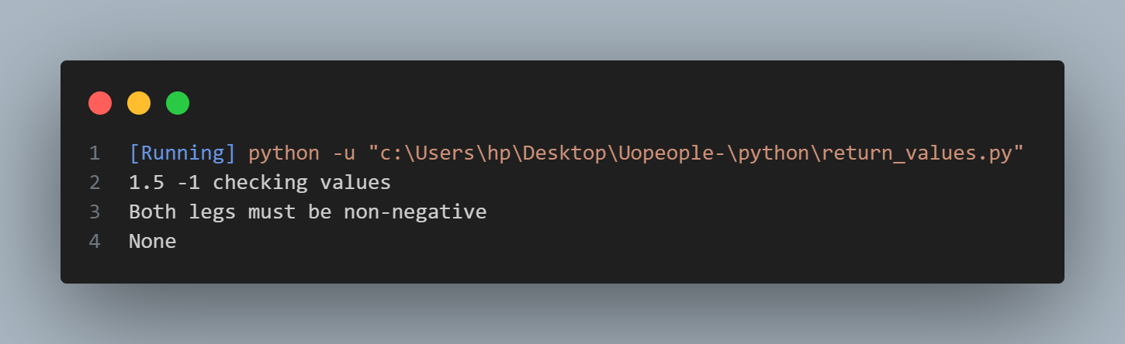

*Code output for p1, fig.2*

This explains the first possibility to check when debugging a function, The error was as a result of the inaccurate value that was passed into the function argument, which couldn’t pass the precondition checks that was implemented, And returned **None .**

**Example for the 2st possibility**

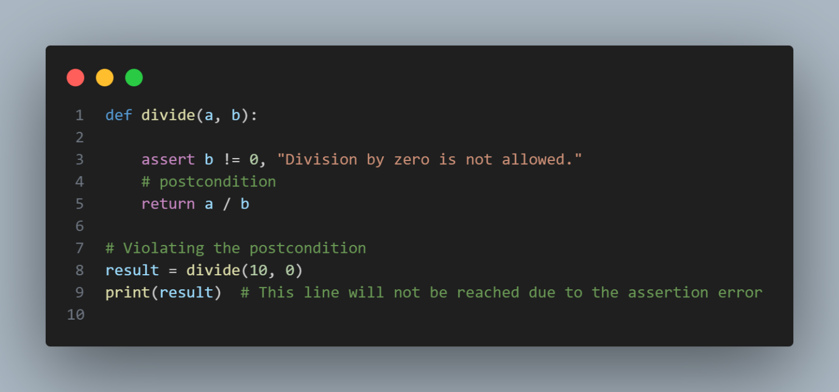

*Code output for p2, fig.3*

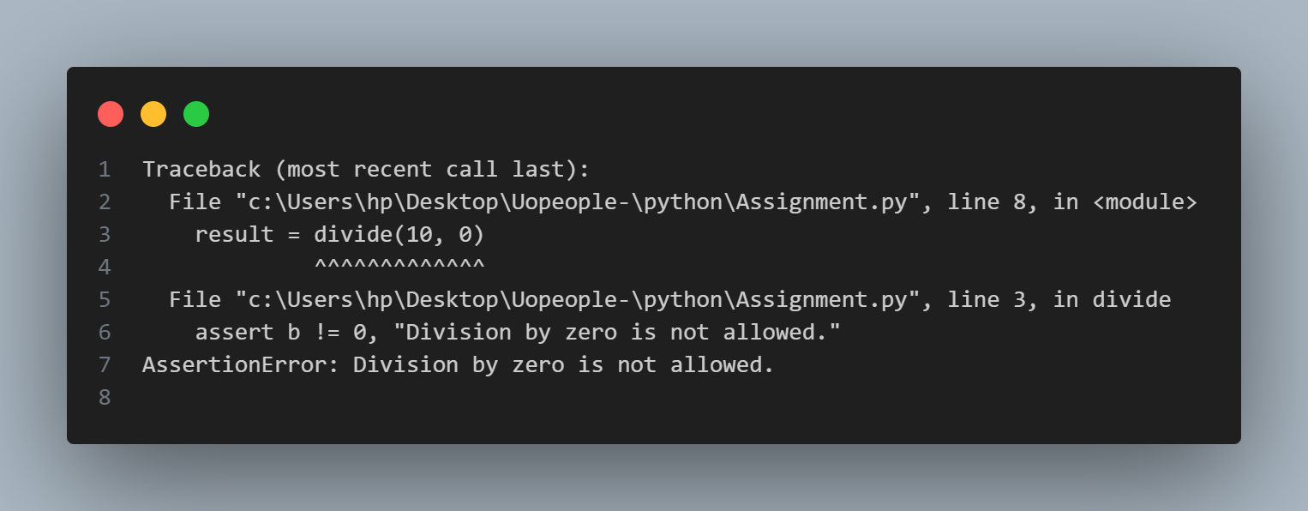

*Code output for p2, fig.4*

This explaines the second possibility when debugging a function, This error where caused as a result of violation the postconditions. I also added an assertion to provide a stack trace on the actual cause of the error.

**References**

Downey, A. (2015,). Think Python: How to think like a computer scientist ,*Chapter 1 -Fruitful functions (pp. 6.8)*

<https://greenteapress.com/thinkpython2/thinkpython2.pdf>

Eric C.R. Hehner in his book , *A Practical Theory of Programming:***Program Theory** *(page:208)*

*[A Practical Theory of Programming](https://books.google.com.ng/books?hl=en&lr=&id=fSrrBwAAQBAJ&oi=fnd&pg=PP10&dq=A+Practical+Theory+of+Programming&ots=lyxujNK_fs&sig=G_JXXgfgbtgLWnwzKBIa3aXga3A&redir_esc=y" \l "v=onepage&q=A%20Practical%20Theory%20of%20Programming&f=false)*